Specials
Gym Monday (2nd) 1:20 – 2:05 pm Wednesday (3rd) 1:20 – 2:05 pm

Spanish Tuesday & Thursday (2nd) 12:45 – 1:15 pm Tuesday & Thursday (3rd) 1:20 – 1:50 pm
Computers Monday (3rd) 1:20 – 2:05 pm Wednesday (2nd) 1:20 – 2:05 pm
Art Friday (3rd) 1:20 – 2:05 pm Friday (2nd) 2:10 – 2:55 pm
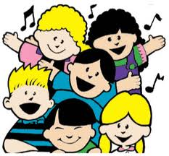Music Tuesday (3rd) 12:45 – 1:15 pm Tuesday (2nd) 1:20 – 1:50 pm
Thursday (3rd) 12:45 – 1:15 pm Thursday (2nd) 1:20 – 1:50 pm
Library Friday (every other) 10:00 – 10:40 am

